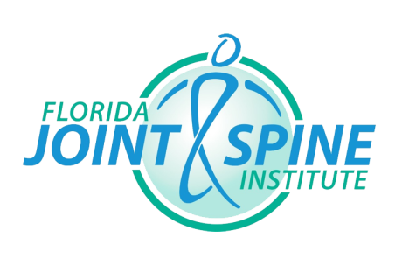
Florida Joint & Spine Institute, P.A.
6325 US Hwy 27 N, Ste 200 Sebring, FL 33870
Phone: 863.385.2222 | Fax: 863.382.8765
Floridajointspine.com

Application for 2-day Shadowing Experience

This program involves a 2-day observation period at Florida Joint & Spine Institute for a maximum 16-hour experience. FJSI will accept 1 eligible student each month for the shadowing experience. Accepted students will shadow and observe one or more of our providers comprising of a physician, physician assistant, or nurse practitioner practicing at FJSI during their patient clinics.
Please note that students in this program are not eligible to observe surgical procedures. Students may request a specialty within FJSI to observe, but placement into the requested specialty is not guaranteed. At this time, Florida Joint & Spine Institute does not support shadowing programs for high school students 18 years and younger.
To apply, send completed application to:
Florida Joint & Spine Institute
c/o Human Resources
6325 US Hwy 27 N, Ste 200
Sebring, FL 33870
or fax to:
863.382.8765

FJSI cannot guarantee placement for all applicants. Positions will be filled based on the order of applications received, applicant eligibility, and the availability of FJSI providers. Applications will be kept on file throughout the school semester in which the student has applied. Incomplete applications will not be considered. Student may reapply each semester, and are eligible to complete this experience twice per year.

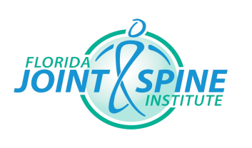
Florida Joint & Spine Institute
6325 US Hwy 27 N, Ste 200 Sebring, FL 33870
Phone: 863.385.2222 Fax: 863.382.8765

Application for 2-day Shadowing Experience

Name:____________________________________________________________________

Cell Phone: ______________________________________________________________

Address: _________________________________________________________________

_________________________________________________________________

Email: ____________________________________________________________________

Year in School: ____________________________ Anticipated Graduation Term/Year: ______________

Major/Area of Study: ___________________________________________________
Semester you wish to apply for: ____ Spring _____Summer ____ Fall
Note your availability for the semester in which you are applying on the table below:
Day | 8-9 am | 9-10 am | 10-11am | 11-12pm | 12-1 pm | 1-2 pm | 2-3 pm
Monday
Tuesday
Wednesday
Thursday
Friday |  |  |  |  | N/A | N/A | N/A

Are you 18 years of older? ____ Yes ____ No
Have you completed two semesters of Anatomy & Physiology with a minimum grade of “B”? ____ Yes ____ No
Briefly explain why you are interested in this program and/or orthopedic medicine:

_____________________________________________________________________________________________________________________________________________________________________________________________________________________________________________________________________________________________________________________________________________________________________________________________________________________________________________________________________________________________________________________________________________________________________________________________________________________________
Florida Joint & Spine Institute
Sebring | Lake Wales | Winter Haven | Kissimmee
CONFIDENTIALITY DISCLAIMER FOR SHADOWING APPLICANTS
I understand and agree that all confidential information that is written or discussed at Florida Joint & Spine Institute is highly confidential. Confidential information includes patient information, employee information, financial information, computer systems information and information proprietary to this organization and its owners. You may learn of or have access to some or all of this confidential information through the computer system, patient records, or through volunteer activities.
I understand that violations of these obligations may subject you to legal consequences that could include but not be limited to prosecution and litigation. Further, by signing this Confidentiality Disclaimer, I understand that in the event Florida Joint & Spine incurs expenses, including any legal expenses, to address violations of this Confidentiality Disclaimer that I may responsible for reimbursement of such expenses and further that Florida Joint & Spine Institute my offset such expenses from any compensation owed to me.
As a volunteer you agree with the following:
- I will use confidential information only as needed to perform my legitimate duties as a volunteer.
- I will only access information for which I have a need to know.
- I will not in any way divulge, copy, release, sell, loan, review, alter, or destroy any confidential information except as properly authorized within the scope of my professional activities affiliated with this organization.
- I will not misuse confidential information or carelessly care for confidential materials.
- I will not discuss patient, company or employee confidential information outside the context of my daily responsibilities and I will not discuss such information in from of, or in the hearing distance of those who do not have the need to know.
- I will safeguard my access codes or any other authorizations that allow me to access to confidential information.
- I will report activities by any individual or entity that I suspect may compromise the integrity of confidential information.
- I understand that my obligations under this agreement will continue after termination of my volunteer work.
- All medical records shall be the property of the Company.
By signing this agreement, I attest that I have read and understand the above information and agree to adhere to this organization’s confidentiality policies.
_____________________________________________________________________________________________________________________
PRINT NAME HERE

_____________________________________________________________________________________________________________________
SIGNATURE

